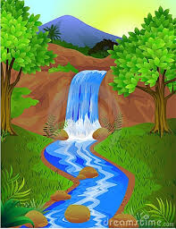
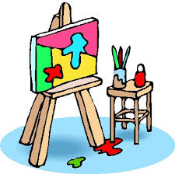
Painting Competition
Date -09\11\2022
Timing – 11am to 1pm
Venue- DA/DH LAB
6th floor
Incharge- Dr Aparna Singh
Rules
- A3 size sheet or Canvas can be used only
- Choice of colors can be of participants choice
- Themes-
Pg- MODERN ART
4th year – ART OF DENTISTRY
3rd year – FESTIVALS
1st year – NATURE
- Time limit -2 hours
All the participants are directed to be present for the event
For further queries please contact the in charge and volunteer

